**Daniel Wild Hotel Final Project**

**Table Of Contents**

**Introduction**

For my final project I have made a hotel booking system for a hotel called the Sunshine Hotel. It is a kind of parody because it is not serious as my idea was to do something different from everyone else so it is a booking system for the worst hotel ever.

**Concept**

Create a booking system for a hotel using C# and windows forms to create a program which shows off the hotel lets the person add their info into a database then choose all things to do with a holiday like a room, meal, activities, transport then check in at the right day and check out on the right day pay for everything, write a review then leave.

**Features**

1. Database
2. hotel photos
3. CRUD (create, read, update,delete)
4. activity info
5. food info
6. transport info
7. room info
8. TripAdvisor info
9. Room availability system
10. Check in Check out system
11. review system

**Objective**

Create a system that can have people add their details into a database which has name, contact number, Address, and number of guests staying then choose a room for select date which will be check against other dates in the database to see which rooms are available then choose activities to do, food to order and transport to book which is all add to the database under that person's name so that they can check in on the right day then check out on the right day and pay for everything which the program will total for them.

**Coding Objectives**

1. connect to an SQL database
2. allow user to add info, read info, update info and delete info
3. allow user to book activities, meal and transport with prices
4. allow user to book rooms on dates which will be checked against the database for availability
5. hold and pass info across tabs from textboxes into database or the over way around
6. check dates in the database against the real date
7. tell people in the database if the can check in, they are late to check in, can not check in yet, have to check out today or they are late to check out
8. add up all prices when the person checks out
9. remove info from database when checked out

**Design Objectives**

1. show database info in datagrid views
2. show text in text boxes
3. use check lists to let user choose activities, food and vehicles
4. use database clicks to check room availability which will be colour coded
5. open different forms for more info on rooms and reviews
6. add up all prices using text boxes

**Design Interface**

V1

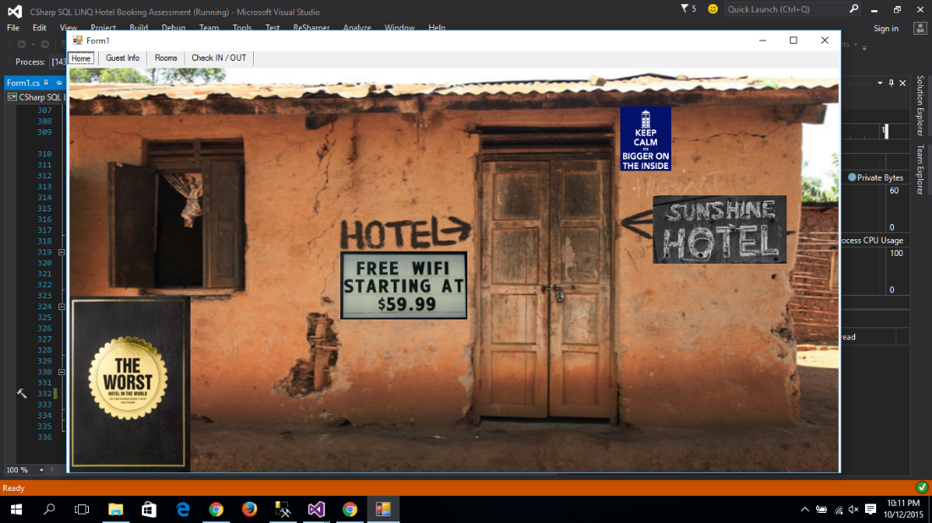

the opening screen has a photo of the hotel with funny signs on it. The program has 4 tabs which run it at the top which can be switched between.

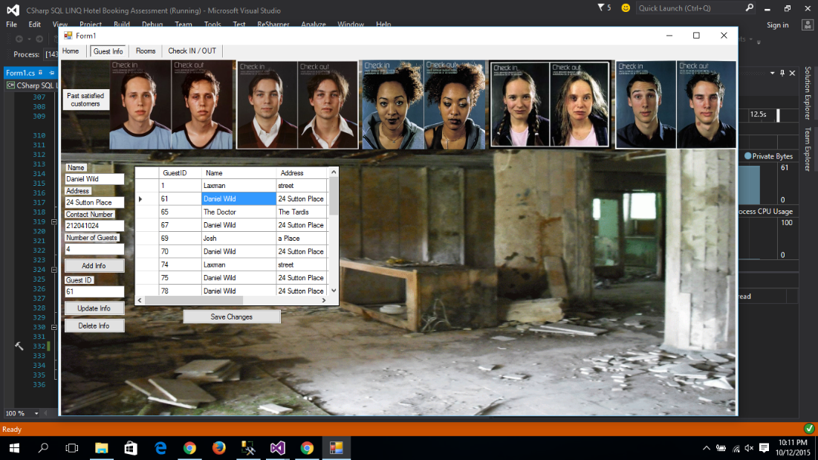

The guest tab has a datagrid view which shows the info from the database with text boxes which have the info from the datagrid when someone is selected if not they are blank and can be written in to add new info.

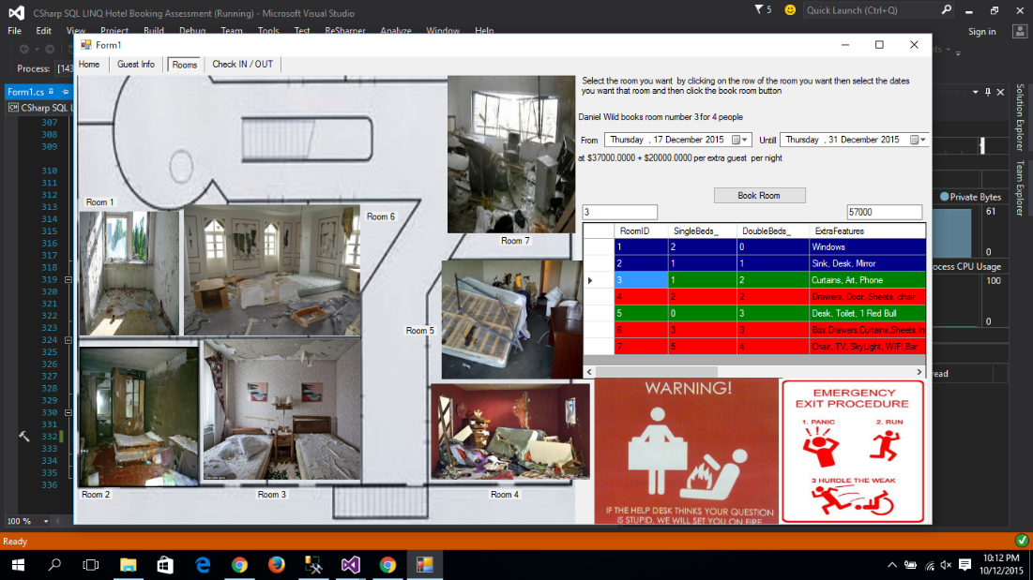

The room tab has two datatime selectors which you put your from and till dates in then click on the room you want it will go green if it is available, blue if it is but you have to many people you can put the other people in another room and red if it is already booked on those dates. you hit the button to add all the info to the database.

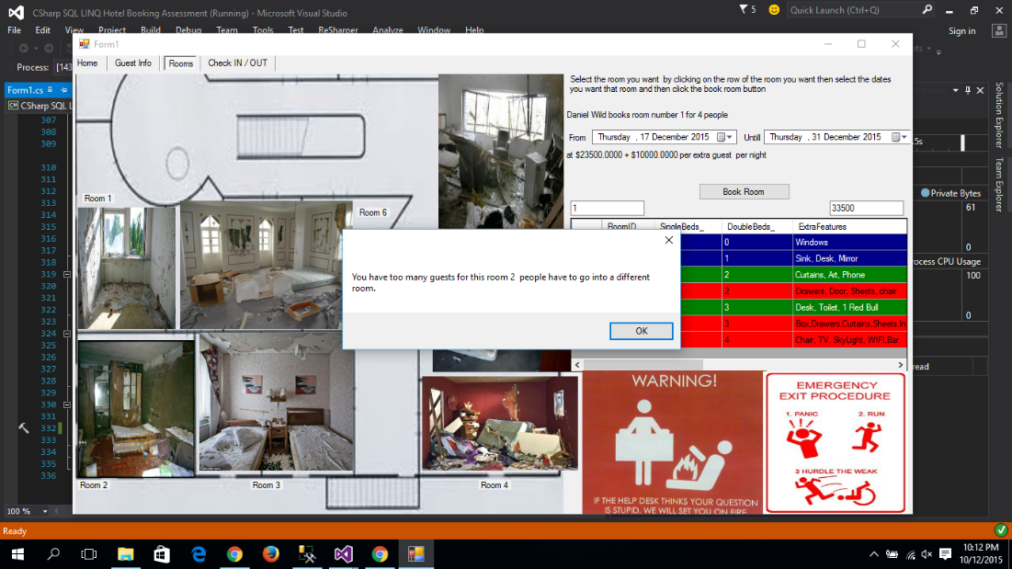

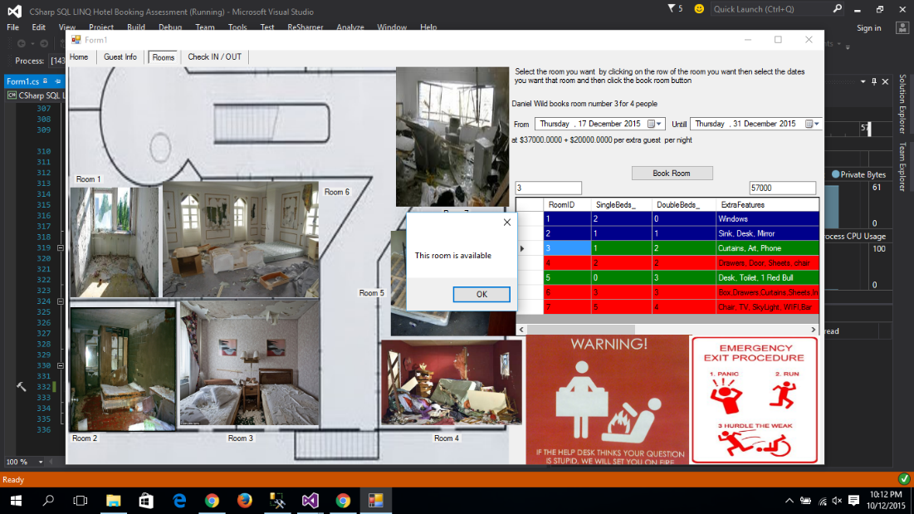

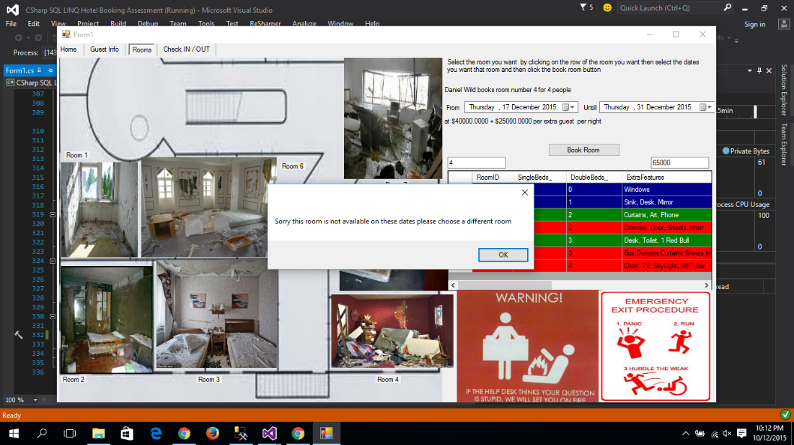

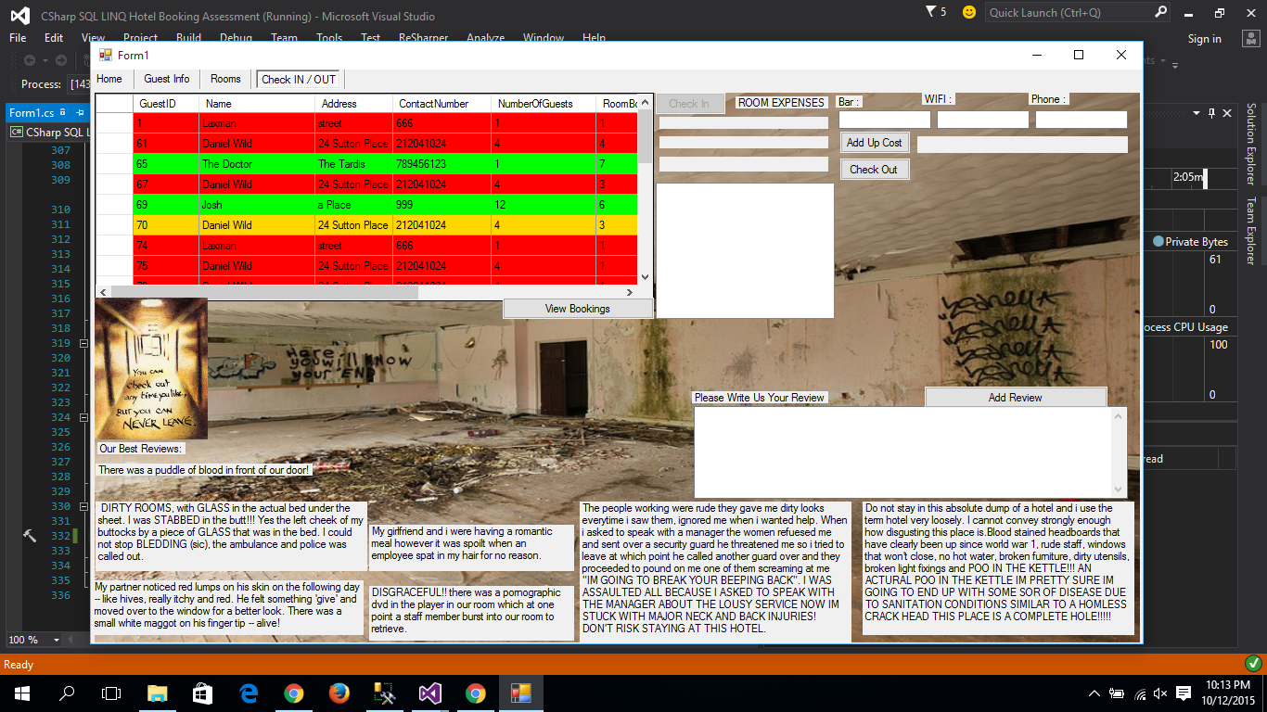

The check in/out tab has a datagrid view which has all the database info of each person which turn dark green if you can check in now, light green if you are late to check in, yellow if you cannot check in yet, blue if you have to check out today or red if you are late to check out. Then there are textboxes which tell you the price of the room calculated by the room price times the days stayed, you then add the cost of the room bar, wifi and phone which is all added together. you can also right a review and read other peoples.

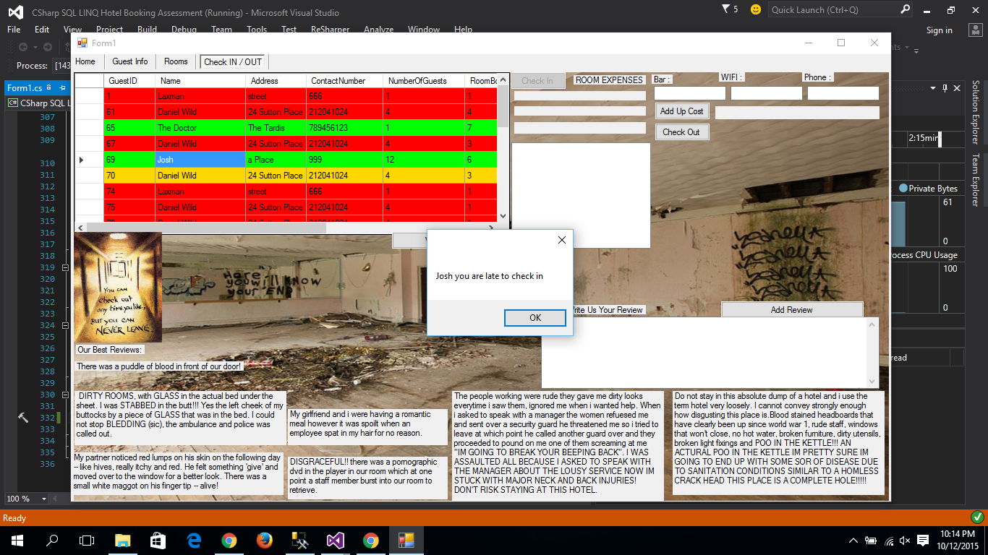

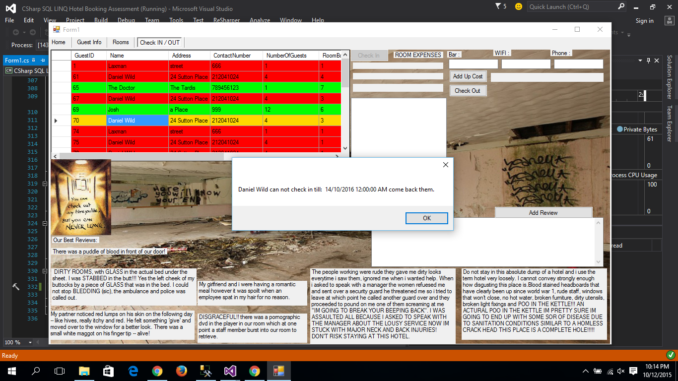

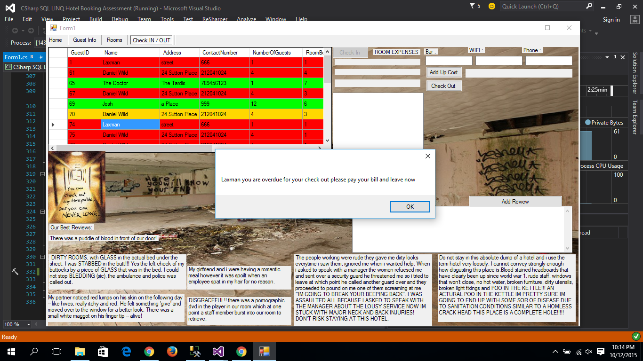

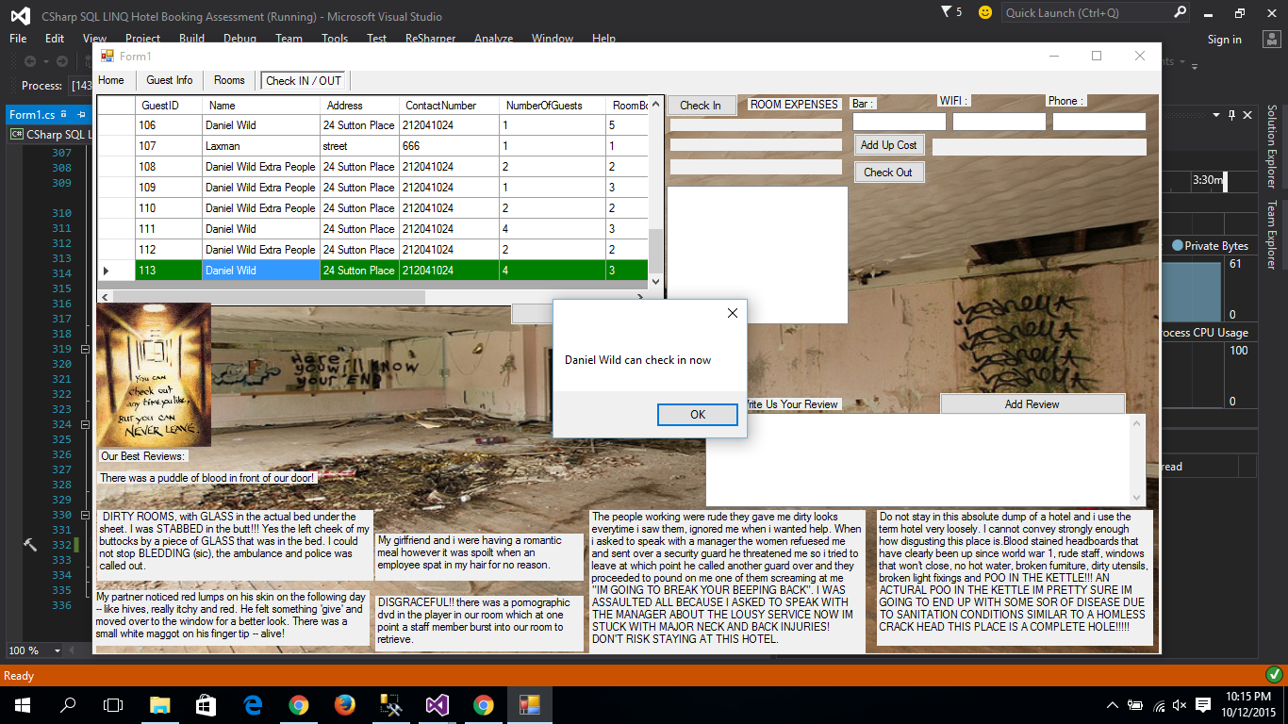

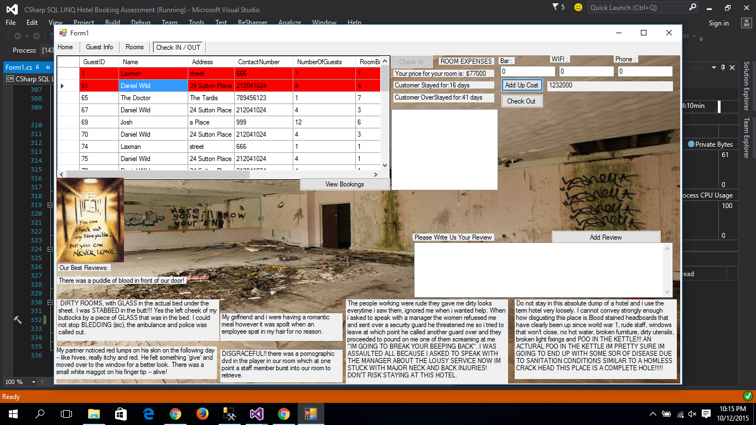

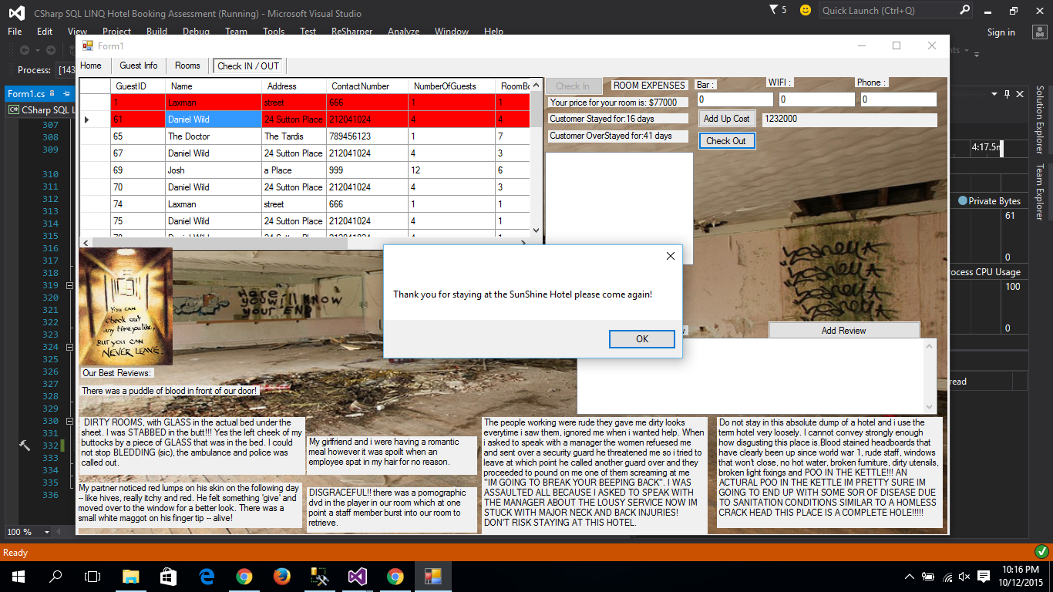

V2

Things changed or added

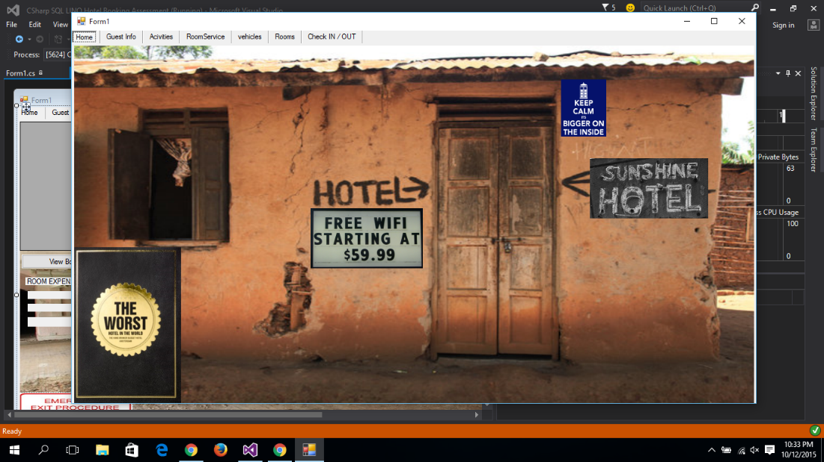

New tabs added Activities, food services and vehicles.

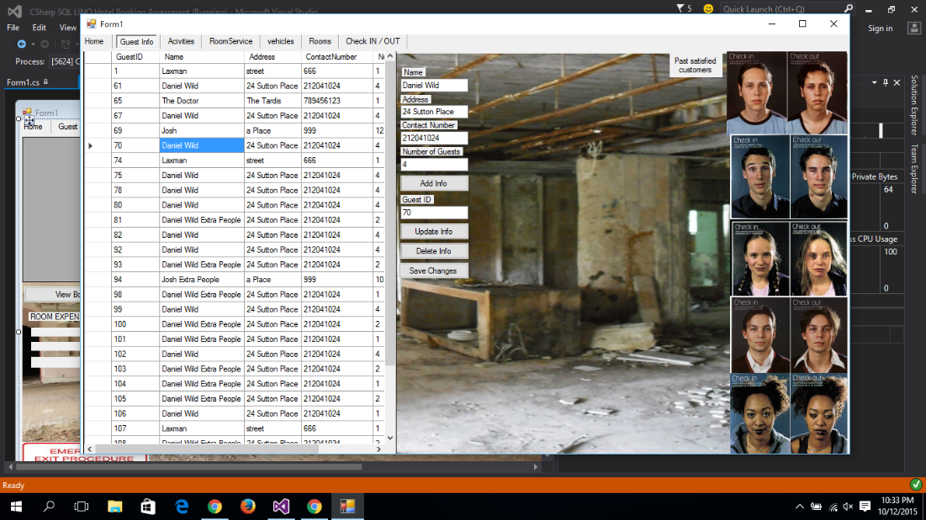

The Guest tab has had the datagridview made bigger so that you do not have to scroll sideways and less down and up. the past satisfied customers have also been moved to the side.

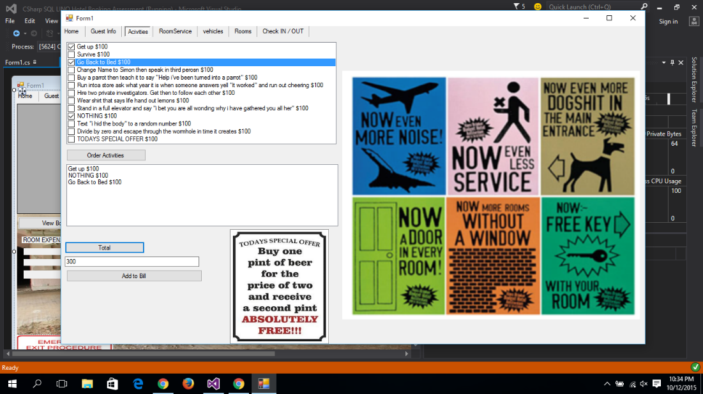

The activities tab has a list checkbox of things to do that can be book by selecting one then clicking order then selecting others. it then gives you a list of the ordered and the total cost.

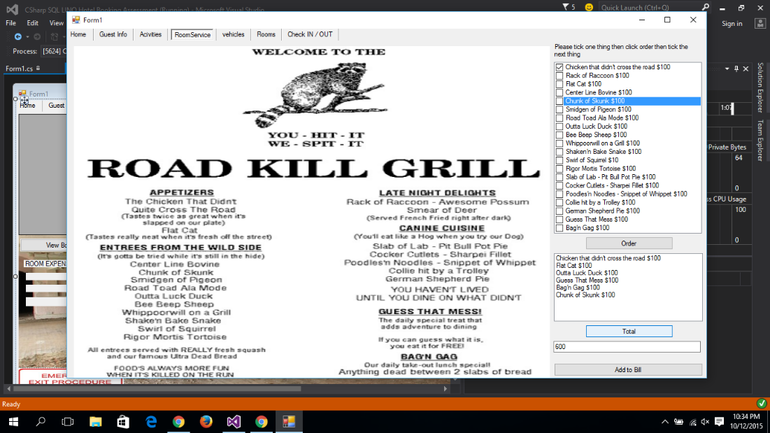

The room service tab has a menu and a check list box to choose the meals you want the total is then added to the check in/out tab in the database

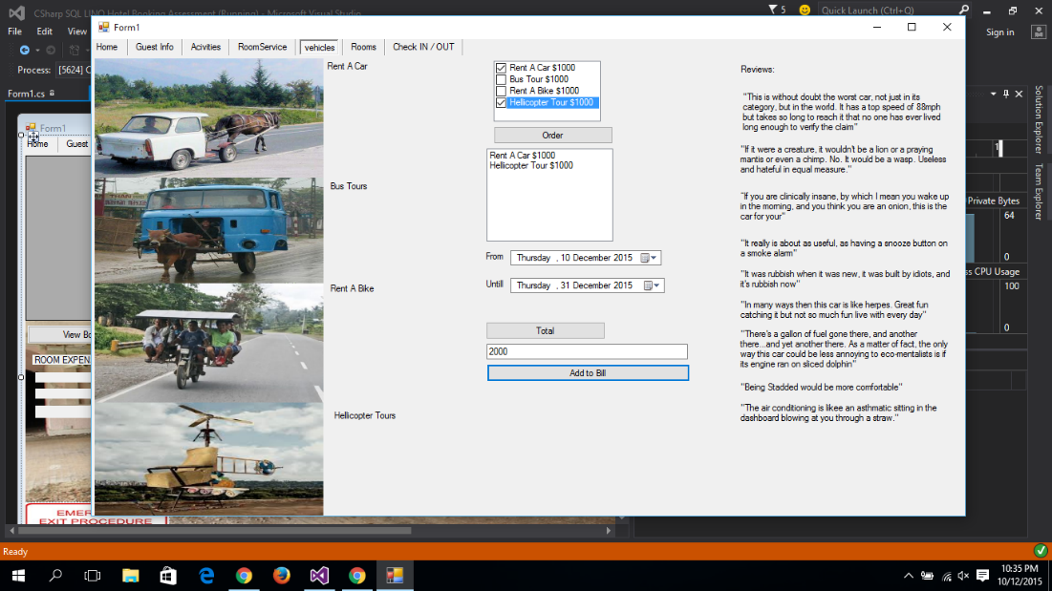

The vehicle tab has the same thing to order each thing which is added to the bill.

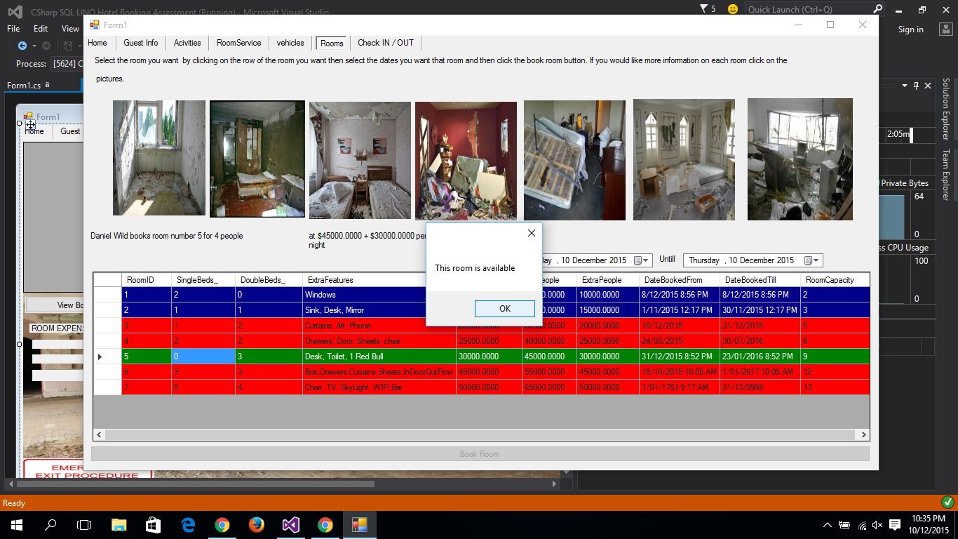

The room tab has been changed the datagridview has been made bigger and the pictures of the rooms you then click on each room picture for more info.

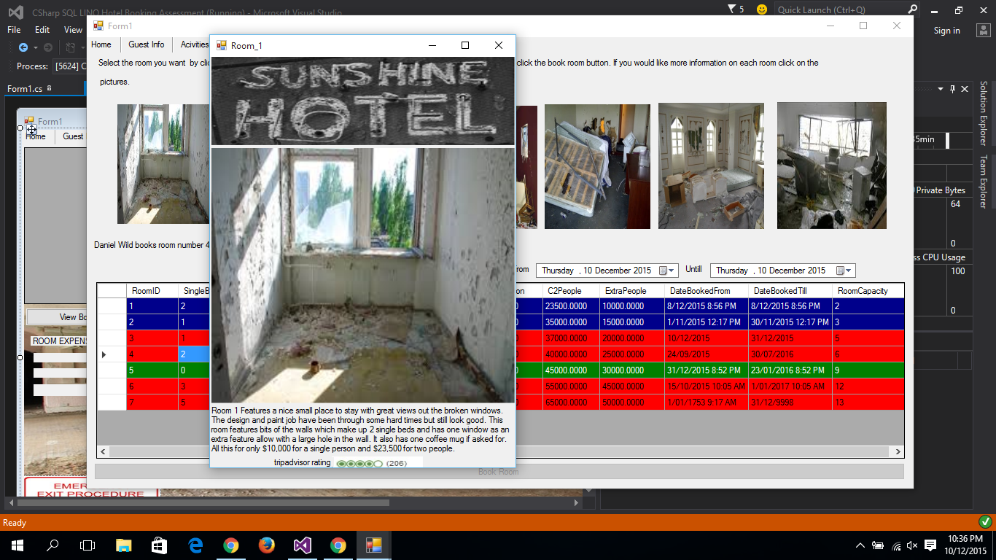

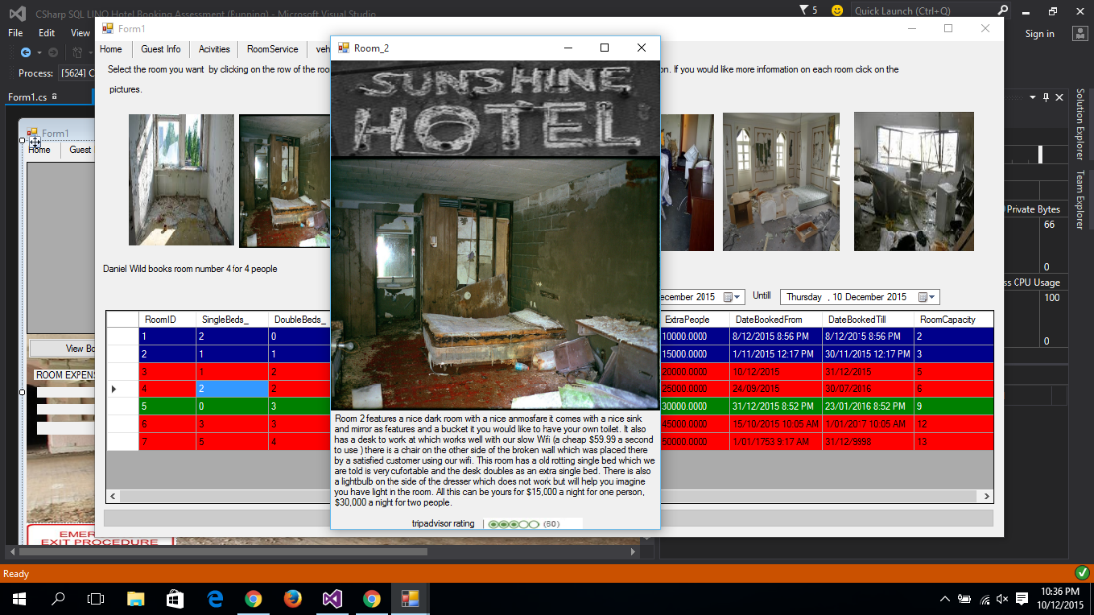

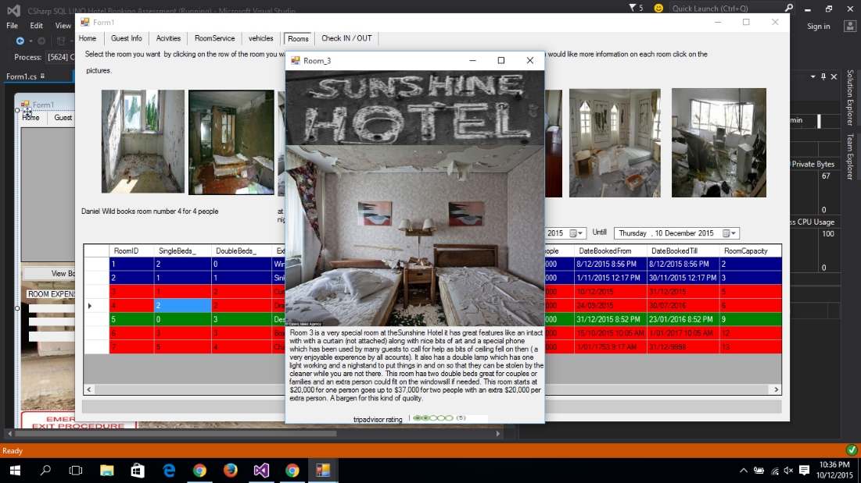

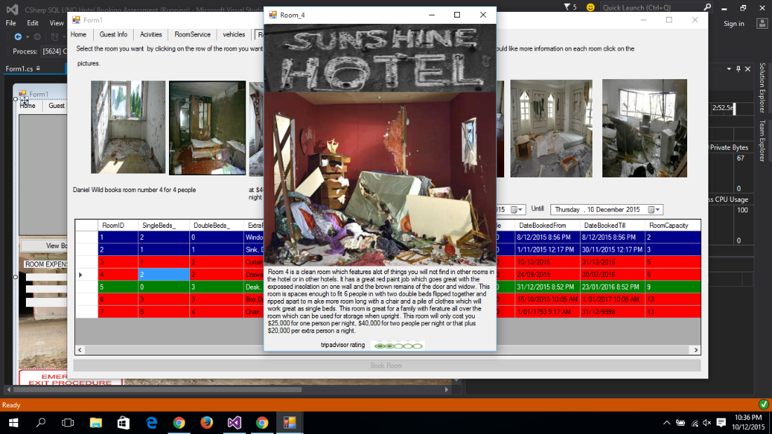

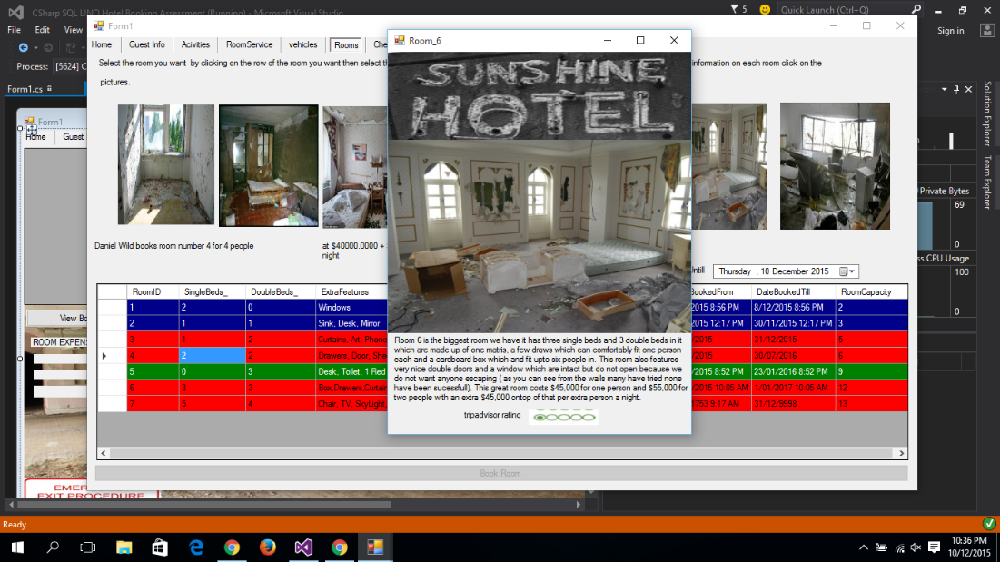

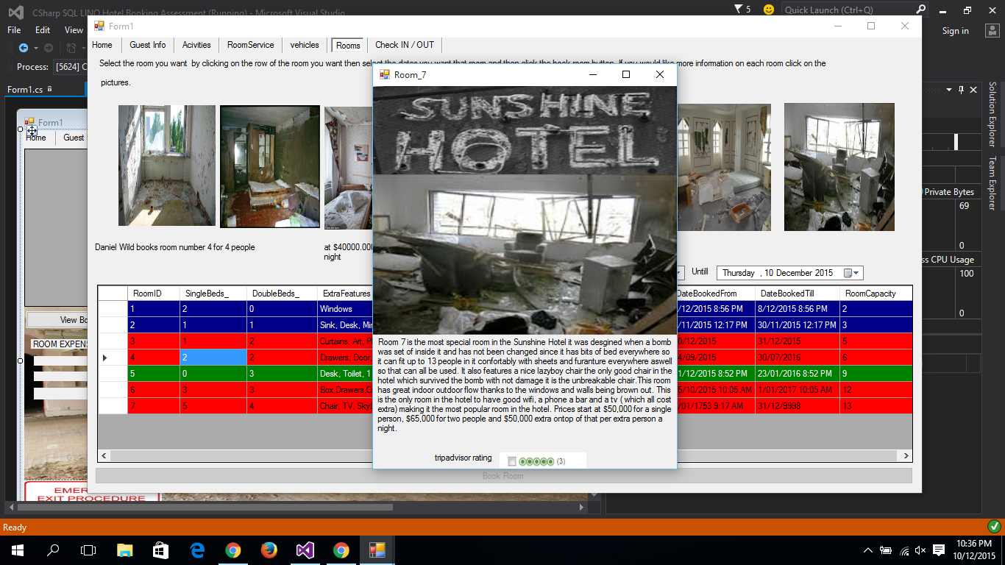

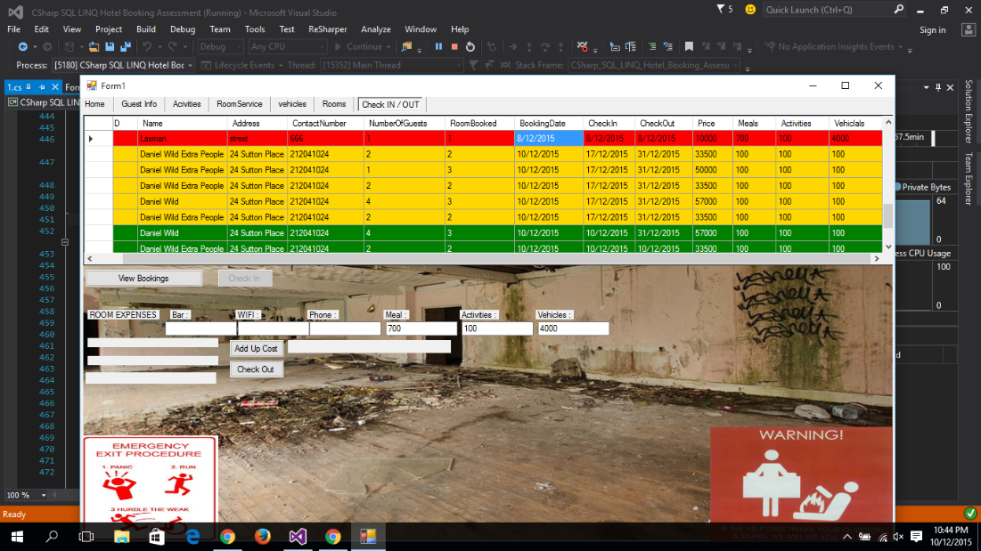

The Check in out tab has had the datagridview made bigger and the textboxes moved down and made bigger also it has been made cleaner with the reviews moved to the review form.

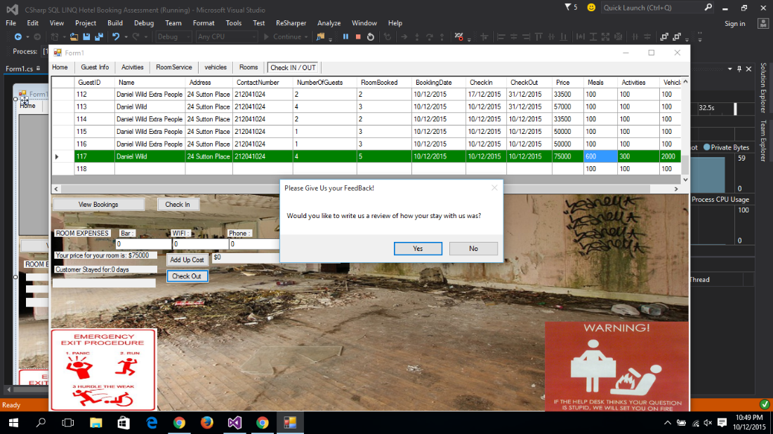

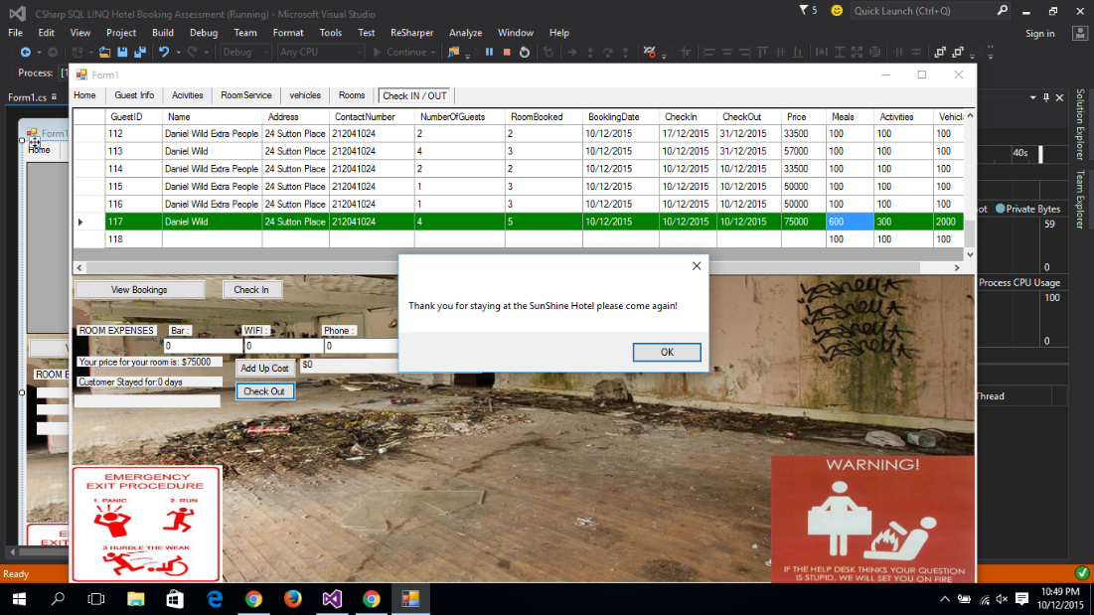

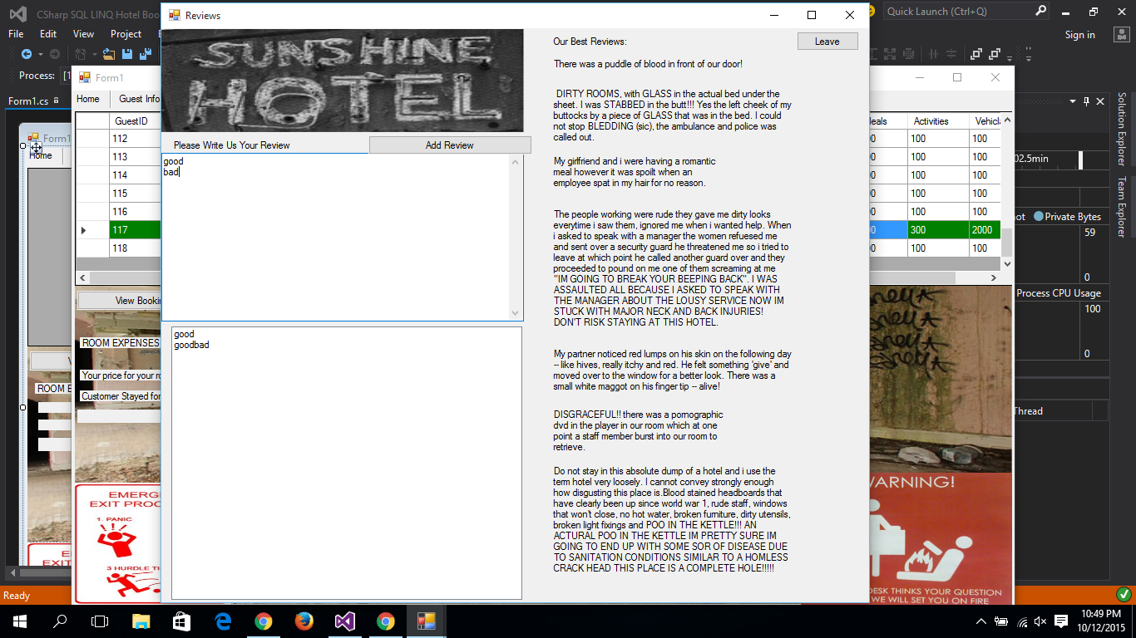

When you click checkout the program will ask you with you want to review your stay which if the answer is yes the Review form will be opened meaning you can add reviews, read other then clcik leave. If you click no the messagebox will stay thank you for staying.

.

You click leave this form will appear then you will be taken back the main form with check in check out tab.

**Summary**

This program has been very fun to make over the last two terms I think it is my best work in C# and will be a very good example to show to people when I am trying to get a job. It has been a good chance to go back through this old work and improve it using other things I have learnt after it was finished the first time.